TEACHER:MWALE CHIPO

KENNETH KAUNDA SECONDARY SCHOOL DESIGN AND TECHNOLOGY DEPARTMENT
LESSON PLAN

SUBJECT: DESIGN AND TECHNOLOGY CLASS:…… … DATE:……/……./20…. DURATION:………….
BOYS:…………………… GIRLS ………………………………………. TOTAL OF PUPILS…
TOPIC: LOCUS SUBTOPIC: INVOLUTE OF A CIRCLE
LEARNING OUTCOMES LSBAT
- To draw the involute of a circle
RATIONALE
Knowledge: Special Curves: Involute.
Skills: Tracing paths of special curves Application of special curves in construction
Values. Appreciation of loci in design work. Awareness of the construction of special curves
TEACHING AIDS
……………………………………………………………………………………………………………………………………………

PART | LESSON CONTENT | METHOD OLOGY | LEARNER ACTIVITY
introductio n | - Recap on the previous lesson | Questions and answers | Provide answers
Developm ent | LOCUS  INVOLUTE  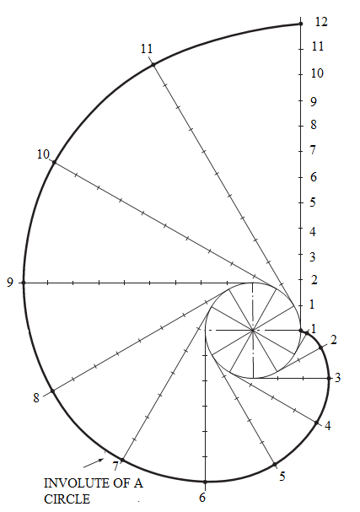  METHOD OF CONSTRUCTION  - Draw the circle and divide the circumference into 12 equal parts  - Draw horizontal lines from 0, 1, 2,3…….  - Divide the line from 0 into 12 units as the circumference of the circle and erect perpendiculars. With the intersection of the perpendicular 1,2,3,4… and horizontal circle centre lines as centres, draw circles the same radius as the first circle.  - Circle with centre perpendicular 1 cuts horizontal line 1 and circle with centre perpendicular 2 cuts horizontal line 1 etc.  - A curve drawn through these points gives the required cycloid
Application | CLASS EXERCISE  A circle 50 mm diameter rests on a horizontal line.  i. Construct the involute to this circle | Questions And Answers | Provide answers
Conclusion | - Recap on the main steps and points | V/E

TEACHER:MWALE CHIPO

KENNETH KAUNDA SECONDARY SCHOOL DESIGN AND TECHNOLOGY DEPARTMENT
LESSON PLAN

SUBJECT: DESIGN AND TECHNOLOGY CLASS:…… … DATE:……/……./20…. DURATION:………….
BOYS:…………………… GIRLS ………………………………………. TOTAL OF PUPILS…
TOPIC: LOCUS SUBTOPIC: INVOLUTE OF A CIRCLE
LEARNING OUTCOMES LSBAT
- To draw the involute of a circle
- To draw a tangent to an involute
RATIONALE
Knowledge: Special Curves: Involute.
Skills: Tracing paths of special curves Application of special curves in construction
Values. Appreciation of loci in design work. Awareness of the construction of special curves
TEACHING AIDS
……………………………………………………………………………………………………………………………………………

PART | LESSON CONTENT | METHODOLO GY | LEARNER ACTIVITY
introductio n | - Recap on the previous lesson | Questions and answers | Provide answers
Developm ent | LOCUS  INVOLUTE  TO DRAW A TANGENT TO AN INVOLUTE  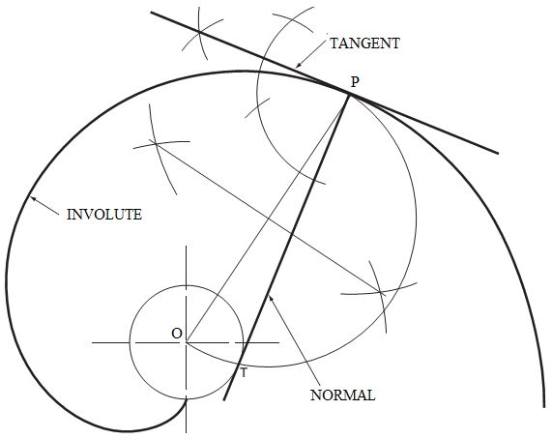  METHOD OF CONSTRUCTION  - Identify a point P, where you wish to draw the tangent.  - Draw an arc of radius equal t the rolling circle, to cut the centre line at O.  - Draw a line from P to T, the point where the semi-circle cuts the base circle. This line is the NORMAL.  - The tangent is drawn by constructing a line at 900 to the normal.
Application | CLASS EXERCISE  A circle 50 mm diameter rests on a horizontal line.  - Construct the involute to this circle  - Construct the tangent to the constructed involute. | Questions And Answers | Provide answers
Conclusion | - Recap on the main steps and points | V/E

TEACHER:MWALE CHIPO

KENNETH KAUNDA SECONDARY SCHOOL DESIGN AND TECHNOLOGY DEPARTMENT
LESSON PLAN

SUBJECT: DESIGN AND TECHNOLOGY CLASS:…… … DATE:……/……./20…. DURATION:………….
BOYS:…………………… GIRLS ………………………………………. TOTAL OF PUPILS… TOPIC: LOCUS SUBTOPIC: ARCHIMEDEAN SPIRAL LEARNING OUTCOMES LSBAT
- Construct paths traced by moving points
RATIONALE
Knowledge: Special Curves: Archimedean spiral,
Skills: Tracing paths of special curves Application of special curves in construction
Values. Appreciation of loci in design work. Awareness of the construction of special curves
TEACHING AIDS
……………………………………………………………………………………………………………………………………………

PART | LESSON CONTENT | METHODOLO GY | LEARNER ACTIVITY
introductio n | - Recap on the previous lesson | Questions and answers | Provide answers
Developme nt | LOCUS  ARCHIMEDEAN SPIRAL  - The path of a point moving uniformly along a straight line rotating about the fixed point at even speed.  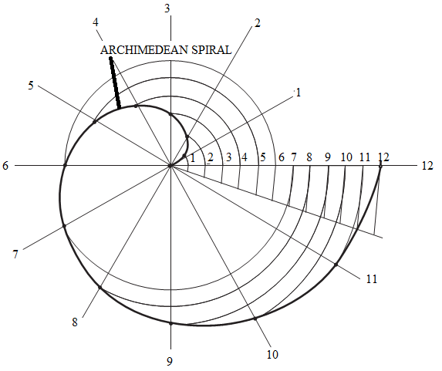  - Draw OA and OB equal to the given radii  - With centre O and radius OB draw a circle and divide it into 12 equal parts  - Divide AB into the same number of equal parts as there are sectors  - With centre O and radius 01 draw an arc to cut radial. Repeat for 2,3,4,5,6,7,8,9,10,11,12  - Draw the curve through the points | Questions And Answers  Demonstration  V/E | Taking note of important points  Provide answers
Application | CLASS EXERCISE  a. Draw two convolutions of an Archimedean spiral such that in two revolutions the radius increases from 18 to 76 mm.. | Questions And Answers | Provide answers
Conclusion | - Recap on the main steps and points | V/E

KENNETH KAUNDA SECONDARY SCHOOL DESIGN AND TECHNOLOGY DEPARTMENT
LESSON PLAN
TEACHER:MWALE CHIPO
SUBJECT: DESIGN AND TECHNOLOGY CLASS:…… … DATE:……/……./20…. DURATION:………….
BOYS:…………………… GIRLS ………………………………………. TOTAL OF PUPILS… TOPIC: LOCUS SUBTOPIC: PARABOLA
LEARNING OUTCOMES LSBAT
- To construct a parabola using rectangle method.
RATIONALE
Knowledge: Special Curves: Parabola
Skills: Tracing paths of special curves Application of special curves in construction
Values. Appreciation of loci in design work. Awareness of the construction of special curves
TEACHING AIDS
……………………………………………………………………………………………………………………………………………

PART | LESSON CONTENT | METHODOLO GY | LEARNER ACTIVITY
introductio n | - Recap on the previous lesson | Questions and answers | Provide answers
Developme nt | LOCUS  PARABOLA  - A parabola is the locus of a point that moves so that its distance from focus equals its perpendicular distance from the directrix.  RECTANGLE METHOD  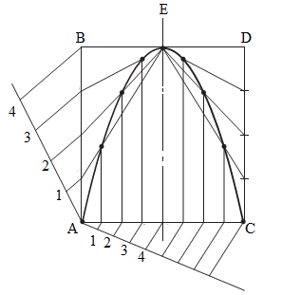  METHODS OF CONSTRUCTION  - Draw the rectangle  - Divide AB, DC, half of rectangle BE and half of rectangle ED into 4 equal parts  - With centre E radiates lines to 1, 2, 3,  - Draw vertical lines from the points on AC to intersect their corresponding radial lines to mark the curve points | Questions And Answers  Demonstration  V/E | Taking note of important points  Provide answers
Application | CLASS EXERCISE  Construct the parabola in a rectangle. Given that AB=CD= 80 and BD=AC=60 | Questions And Answers | Provide answers
Conclusion | - Recap on the main steps and points | V/E

TEACHER:MWALE CHIPO

KENNETH KAUNDA SECONDARY SCHOOL DESIGN AND TECHNOLOGY DEPARTMENT
LESSON PLAN

SUBJECT: DESIGN AND TECHNOLOGY CLASS:…… … DATE:……/……./20…. DURATION:………….
BOYS:…………………… GIRLS ………………………………………. TOTAL OF PUPILS… TOPIC: LOCUS SUBTOPIC: PARABOLA
LEARNING OUTCOMES LSBAT
- To draw a parabola when given the Directrix and focus
RATIONALE
Knowledge: Special Curves: parabola,
Skills: Tracing paths of special curves Application of special curves in construction
Values. Appreciation of loci in design work. Awareness of the construction of special curves
TEACHING AIDS
……………………………………………………………………………………………………………………………………………

PART | LESSON CONTENT | METHOD OLOGY | LEARNER ACTIVITY
introductio n | - Recap on the previous lesson | Questions and answers | Provide answers
Developme nt | LOCUS  PARABOLA  - A parabola is the locus of a point that moves so that its distance from focus equals its perpendicular distance from the directrix.  ECCENTRICITY METHOD  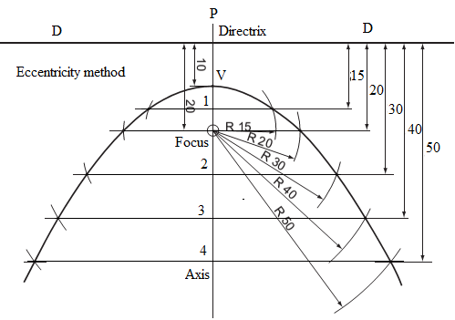  METHODS OF CONSTRUCTION  - Draw the directrix DD and at a convenient point P draw the axis perpendicular to the directrix and indicate the given focus F.  - Bisect PF to give point V. Divide VF into two equal parts and take one of these units and mark points 2,3,4, on the axis from the points on it  - With centre F and P1 as a radius draw an arc each side of axis to cutline 1.  - Repeat the procedure as shown. Draw the parabola
Application | CLASS EXERCISE  Draw the parabola using eccentricity method. Construct the tangent | Questions And Answers | Provide answers
Conclusion | - Recap on the main steps and points | V/E

TEACHER:MWALE CHIPO

KENNETH KAUNDA SECONDARY SCHOOL DESIGN AND TECHNOLOGY DEPARTMENT
LESSON PLAN

SUBJECT: DESIGN AND TECHNOLOGY CLASS:…… … DATE:……/……./20…. DURATION:………….
BOYS:…………………… GIRLS ………………………………………. TOTAL OF PUPILS… TOPIC: LOCUS SUBTOPIC: PARABOLA
LEARNING OUTCOMES LSBAT
- To draw a parabola when given the Directrix and focus
- To draw a tangent to a parabola at a given point on the curve

RATIONALE
Knowledge: Special Curves: parabola,
Skills: Tracing paths of special curves Application of special curves in construction
Values. Appreciation of loci in design work. Awareness of the construction of special curves
TEACHING AIDS
……………………………………………………………………………………………………………………………………………

PART | LESSON CONTENT | METHODOLO GY | LEARNER ACTIVITY
introductio n | - Recap on the previous lesson | Questions and answers | Provide answers
Developme nt | LOCUS  TO DRAW A TANGENT TO A PARABOLA AT A GIVEN POINT ON THE CURVE  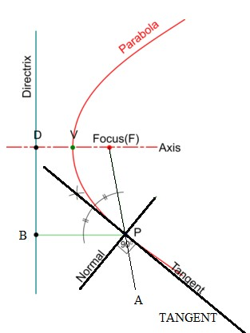  METHODS OF CONSTRUCTION  - Draw the parabola and indicate the focus F and the given point P on the curve  - Draw PB parallel to axis  - Extend a line from F through P (PA)  - Bisect angle BPA. A normal is a line perpendicular to the tangent from P
Application | CLASS EXERCISE  Draw the parabola using eccentricity method. Construct the tangent | Questions And Answers | Provide answers
Conclusion | - Recap on the main steps and points | V/E

TEACHER:MWALE CHIPO

KENNETH KAUNDA SECONDARY SCHOOL DESIGN AND TECHNOLOGY DEPARTMENT
LESSON PLAN

SUBJECT: DESIGN AND TECHNOLOGY CLASS:…… … DATE:……/……./20…. DURATION:………….
BOYS:…………………… GIRLS ………………………………………. TOTAL OF PUPILS… TOPIC: LOCUS SUBTOPIC: CYCLOID
LEARNING OUTCOMES LSBAT
- Construct paths traced by moving points
RATIONALE
Knowledge: Special Curves: cycloid,
Skills: Tracing paths of special curves Application of special curves in construction
Values. Appreciation of locus in design work. Awareness of the construction of special curves
TEACHING AIDS
PART | LESSON CONTENT | METHODOLO GY | LEARNER ACTIVITY
Introductio n | - Recap on the previous lesson | Questions and answers | Provide answers
Developme nt | LOCUS  CYCLOID  - The path of a point on the circumference of a circle rolling along a straight line.  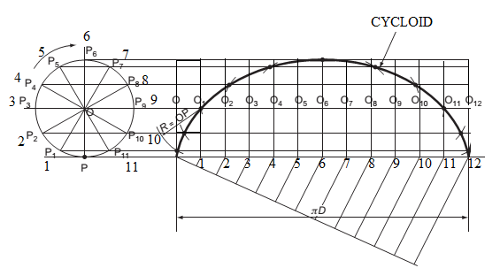  - Draw the circle and divide the circumference into 12 equal parts  - Draw horizontal lines from 0, 1,2,3…….  - Divide the line from 0 into 12 units as the circumference of the circle and erect perpendiculars. With the intersection of the perpendicular 1,2,3,4… and horizontal circle centre lines as centres, draw circles the same radius as the first circle.  - Circle with centre perpendicular 1 cuts horizontal line 1 and circle with centre perpendicular 2 cuts horizontal line 1 etc.  - A curve drawn through these points gives the required cycloid
Application | CLASS EXERCISE  Figure 1 shows a circular wheel 50 mm in diameter with a point P attached to its periphery.  The wheel rolls without slipping along a perfectly straight track whilst remaining in the same plane.  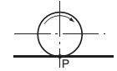 | Questions And Answers | Provide answers
Conclusion | - Recap on the main steps and points | V/E

TEACHER:MWALE CHIPO

KENNETH KAUNDA SECONDARY SCHOOL DESIGN AND TECHNOLOGY DEPARTMENT
LESSON PLAN

SUBJECT: DESIGN AND TECHNOLOGY CLASS:…… … DATE:……/……./20…. DURATION:………….
BOYS:…………………… GIRLS ………………………………………. TOTAL OF PUPILS… TOPIC: LOCUS SUBTOPIC: CYCLOID
LEARNING OUTCOMES LSBAT
- Construct the tangent on the locus of cycloid
RATIONALE
Knowledge: Special Curves: cycloid,
Skills: Tracing paths of special curves Application of special curves in construction
Values. Appreciation of locus in design work. Awareness of the construction of special curves
TEACHING AIDS
……………………………………………………………………………………………………………………………………………

PART | LESSON CONTENT | METHODOLO GY | LEARNER ACTIVITY
introductio n | - Recap on the previous lesson | Questions and answers | Provide answers
Developme nt | LOCUS  CYCLOID TANGENT  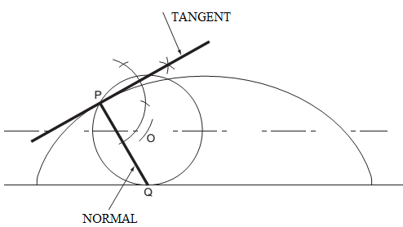  APPLICATIONS OF CYCLOID CURVES:  - used in the design of gear tooth profiles.  - It is also used in the design of conveyor of mould boxes in foundry shops.  - used in kinematics (motion studies) and in mechanism s that work with rolling contact | Questions And Answers  Demonstration  V/E | Taking note of important points  Provide answers
Application | CLASS EXERCISE  Figure 1 shows a circular wheel 50 mm in diameter with a point P attached to its periphery.  The wheel rolls without slipping along a perfectly straight track whilst remaining in the same plane. | Questions And Answers | Provide answers
Conclusion | - Recap on the main steps and points | V/E

TEACHER:MWALE CHIPO

KENNETH KAUNDA SECONDARY SCHOOL DESIGN AND TECHNOLOGY DEPARTMENT
LESSON PLAN

SUBJECT: DESIGN AND TECHNOLOGY CLASS:…… … DATE:……/……./20…. DURATION:………….
BOYS:…………………… GIRLS ………………………………………. TOTAL OF PUPILS…
TOPIC: LOCUS SUBTOPIC: EPICYCLOID
LEARNING OUTCOMES LSBAT
- To construct an epicycloid of rolling circle diameter and tangent
RATIONALE
Knowledge: Special Curves: EPICYCLOID
Skills: Tracing paths of special curves Application of special curves in construction
Values. Appreciation of loci in design work. Awareness of the construction of special curves
TEACHING AIDS
……………………………………………………………………………………………………………………………………………

PART | LESSON CONTENT | METHODOLO GY | LEARNER ACTIVITY
introductio n | - Recap on the previous lesson | Questions and answers | Provide answers
Developme nt | LOCUS  EPI-CYCLOID  - The epi-cycloid is the locus of a point on the circumference of a circle when it rolls, without slipping, along the outside of a circular arc.  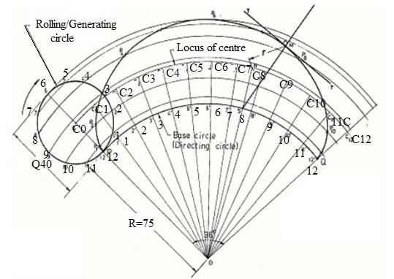  METHOD OF CONSTRUCTION  - Draw and divide rolling circle into 12 equal divisions.  - Transfer the 12 divisions on to the base surface.  - Mark the 12 positions of the circle – centre (C1,C2, …) as the circle rolls on the base surface. .  - Project the positions of the point from the circle.  - Using the radius of the circle and from the marked centres C1,C2,C3 etc cut off the arcs through 1,2,3  - Darken the curve. | Questions And Answers  Demonstration  V/E | Taking note of important points  Provide answers
Application | CLASS EXERCISE  Draw an epicycloid of rolling circle diameter 40 mm which rolls outside another circle (base circle) of 150mm diameter for one revolution | Questions And Answers | Provide answers
Conclusion | - Recap on the main steps and points | V/E

TEACHER:MWALE CHIPO

KENNETH KAUNDA SECONDARY SCHOOL DESIGN AND TECHNOLOGY DEPARTMENT
LESSON PLAN

SUBJECT: DESIGN AND TECHNOLOGY CLASS:…… … DATE:……/……./20…. DURATION:………….
BOYS:…………………… GIRLS ………………………………………. TOTAL OF PUPILS…
TOPIC: LOCUS SUBTOPIC: HYPOCYCLOID
LEARNING OUTCOMES LSBAT
- To construct Hypo-Cycloid of rolling circle diameter and tangent
RATIONALE
Knowledge: Special Curves: Hypo-Cycloid
Skills: Tracing paths of special curves Application of special curves in construction
Values. Appreciation of loci in design work. Awareness of the construction of special curves
TEACHING AIDS
……………………………………………………………………………………………………………………………………………

PART | LESSON CONTENT | METHODOLO GY | LEARNER ACTIVITY
introductio n | - Recap on the previous lesson | Questions and answers | Provide answers
Developme nt | LOCUS  HYPO-CYCLOID  - A hypo-cycloid is the locus of a point on the circumference of a circle when the circle rolls, without slipping, along the inside of a circular arc  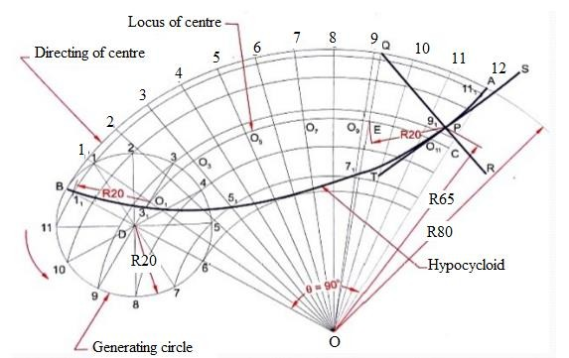  METHOD OF CONSTRUCTION  - With O as centre and radius OB (base circle radius), draw an arc BA.  - The included angle θ = (r/R) x 360°. With O as centre and OB as radius, draw an arc to represent locus of centre.  - Divide arc AB in to 12 equal parts and name them as 1’, 2’, …., 12’. Join O1’, O2’, …, O12’ so as to cut the locus of centres at C1, C2,….C12.  - Taking C1 as centre, and radius equal to r, draws an arc cutting the arc through 1 at P1. Taking C2 as centre and with the same radius, draw an arc cutting the arc through 2 at P2.  - Similarly obtain points P3, P3, …., P12.  - Draw a smooth curve passing through P1,
Application | CLASS EXERCISE  Draw a hypo-cycloid of rolling circle diameter 40 mm which rolls outside another circle (base circle) of 150mm diameter for one revolution | Questions And Answers | Provide answers
Conclusion | - Recap on the main steps and points | V/E

TEACHER:MWALE CHIPO

KENNETH KAUNDA SECONDARY SCHOOL DESIGN AND TECHNOLOGY DEPARTMENT
LESSON PLAN

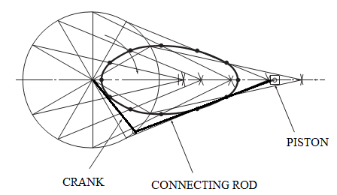
SUBJECT: DESIGN AND TECHNOLOGY CLASS:…… … DATE:……/……./20…. DURATION:………….
BOYS:…………………… GIRLS ………………………………………. TOTAL OF PUPILS…
TOPIC: LOCUS SUBTOPIC: LINK MECHANISM LEARNING OUTCOMES LSBAT
- Construct paths traced by moving points
RATIONALE
Knowledge: Paths of simple mechanisms (maximum of three linkages)
Skills: Tracing paths of moving points on a mechanism
Values. Appreciation of loci in design work. Awareness of the construction of special curves
TEACHING AIDS
……………………………………………………………………………………………………………………………………………

PART | LESSON CONTENT | METHODOLO GY | LEARNER ACTIVITY
introductio n | - Recap on the previous lesson | Questions and answers | Provide answers
Developme nt | LOCUS  A locus  - The path traced out by a point that moves under given definite conditions.  LINK MECHANISM | Questions And Answers  Demonstration  V/E | Taking note of important points  Provide answers
Application | CLASS EXERCISE  Crank OA rotates in an anti-clockwise direction about the fixed point O. A and B are pin joints. Crank BC pivots about the fixed point C.  Plot the locus of point P for one revolution of the crank OA..  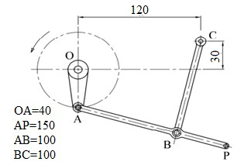 | Questions And Answers | Provide answers
Conclusion | - Recap on the main steps and points | V/E

